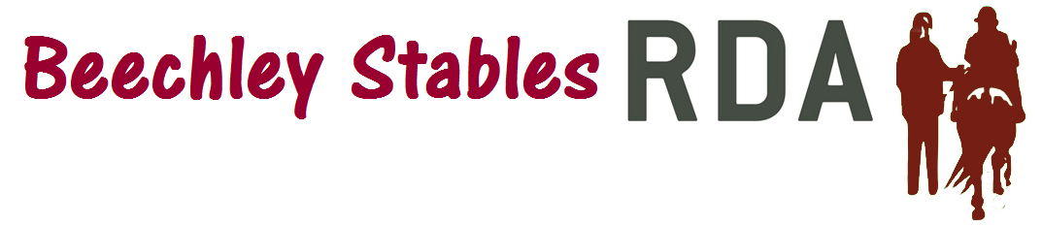
Code of Conduct for Volunteers

These guidelines clarify the conduct that Beechley Stables RDA expects from its volunteers.

Beechley Stables RDA expects its volunteers to act co-operatively with other volunteers and staff ensuring colleagues are treated fairly, politely and
without discrimination and to undertake their duties to a high standard at all times.

- You must not discriminate against any Beechley Stables RDA employee or volunteer on grounds of gender, age, race, disability, sexuality, culture or religious beliefs.

- You must endeavour to promote and protect the interests of all service users, irrespective of gender, age, race, disability, sexuality, culture or religious beliefs.

- You must at all times treat people who have disabilities or mental health problems with dignity and respect.

- Harassment and bullying of staff members, other volunteers or service users is completely unacceptable and will result in a volunteer being asked to leave.

- You are expected to act in a friendly manner towards service users, but to maintain appropriate professional boundaries within the relationship at all times. Relationships of a personal, emotional or sexual nature will result in a volunteer being asked to leave. Such an incident may also lead to the involvement of the Child and Vulnerable Persons Protection Officer.

- You are expected to abide by the Confidentiality Policy, Data Protection Policy and E-Safety Policy.

- You must treat information about service users as confidential within the care team and must not discuss such matters outside of Beechley Stables.

- You must act quickly to protect service users if you have good reason to believe that they are in any way at risk of abuse (By contacting the Child and Vulnerable Adults Protection Officer as set out in the Child and Vulnerable Adults Protection Policy).

- You must not be in possession of nor consume alcohol or prohibited drugs while volunteering at or visiting premises managed by Beechley Stables RDA. The only exception is when the centre manager expressly agrees in advance that alcohol may be consumed in moderation.

- You must not commence duty under the influence of alcohol or prohibited drugs. Managers will insist that volunteers do not come on duty with the smell of alcohol on their breath or where erratic behaviour is apparent.

This policy has been approved & authorised by:

Name:

Position:

Date:

Signature:

